Art & Archaeology in the Outer Hebrides:
Implications for Coastal Erosion Worldwide

An Explorers Club Flag Expedition 2017

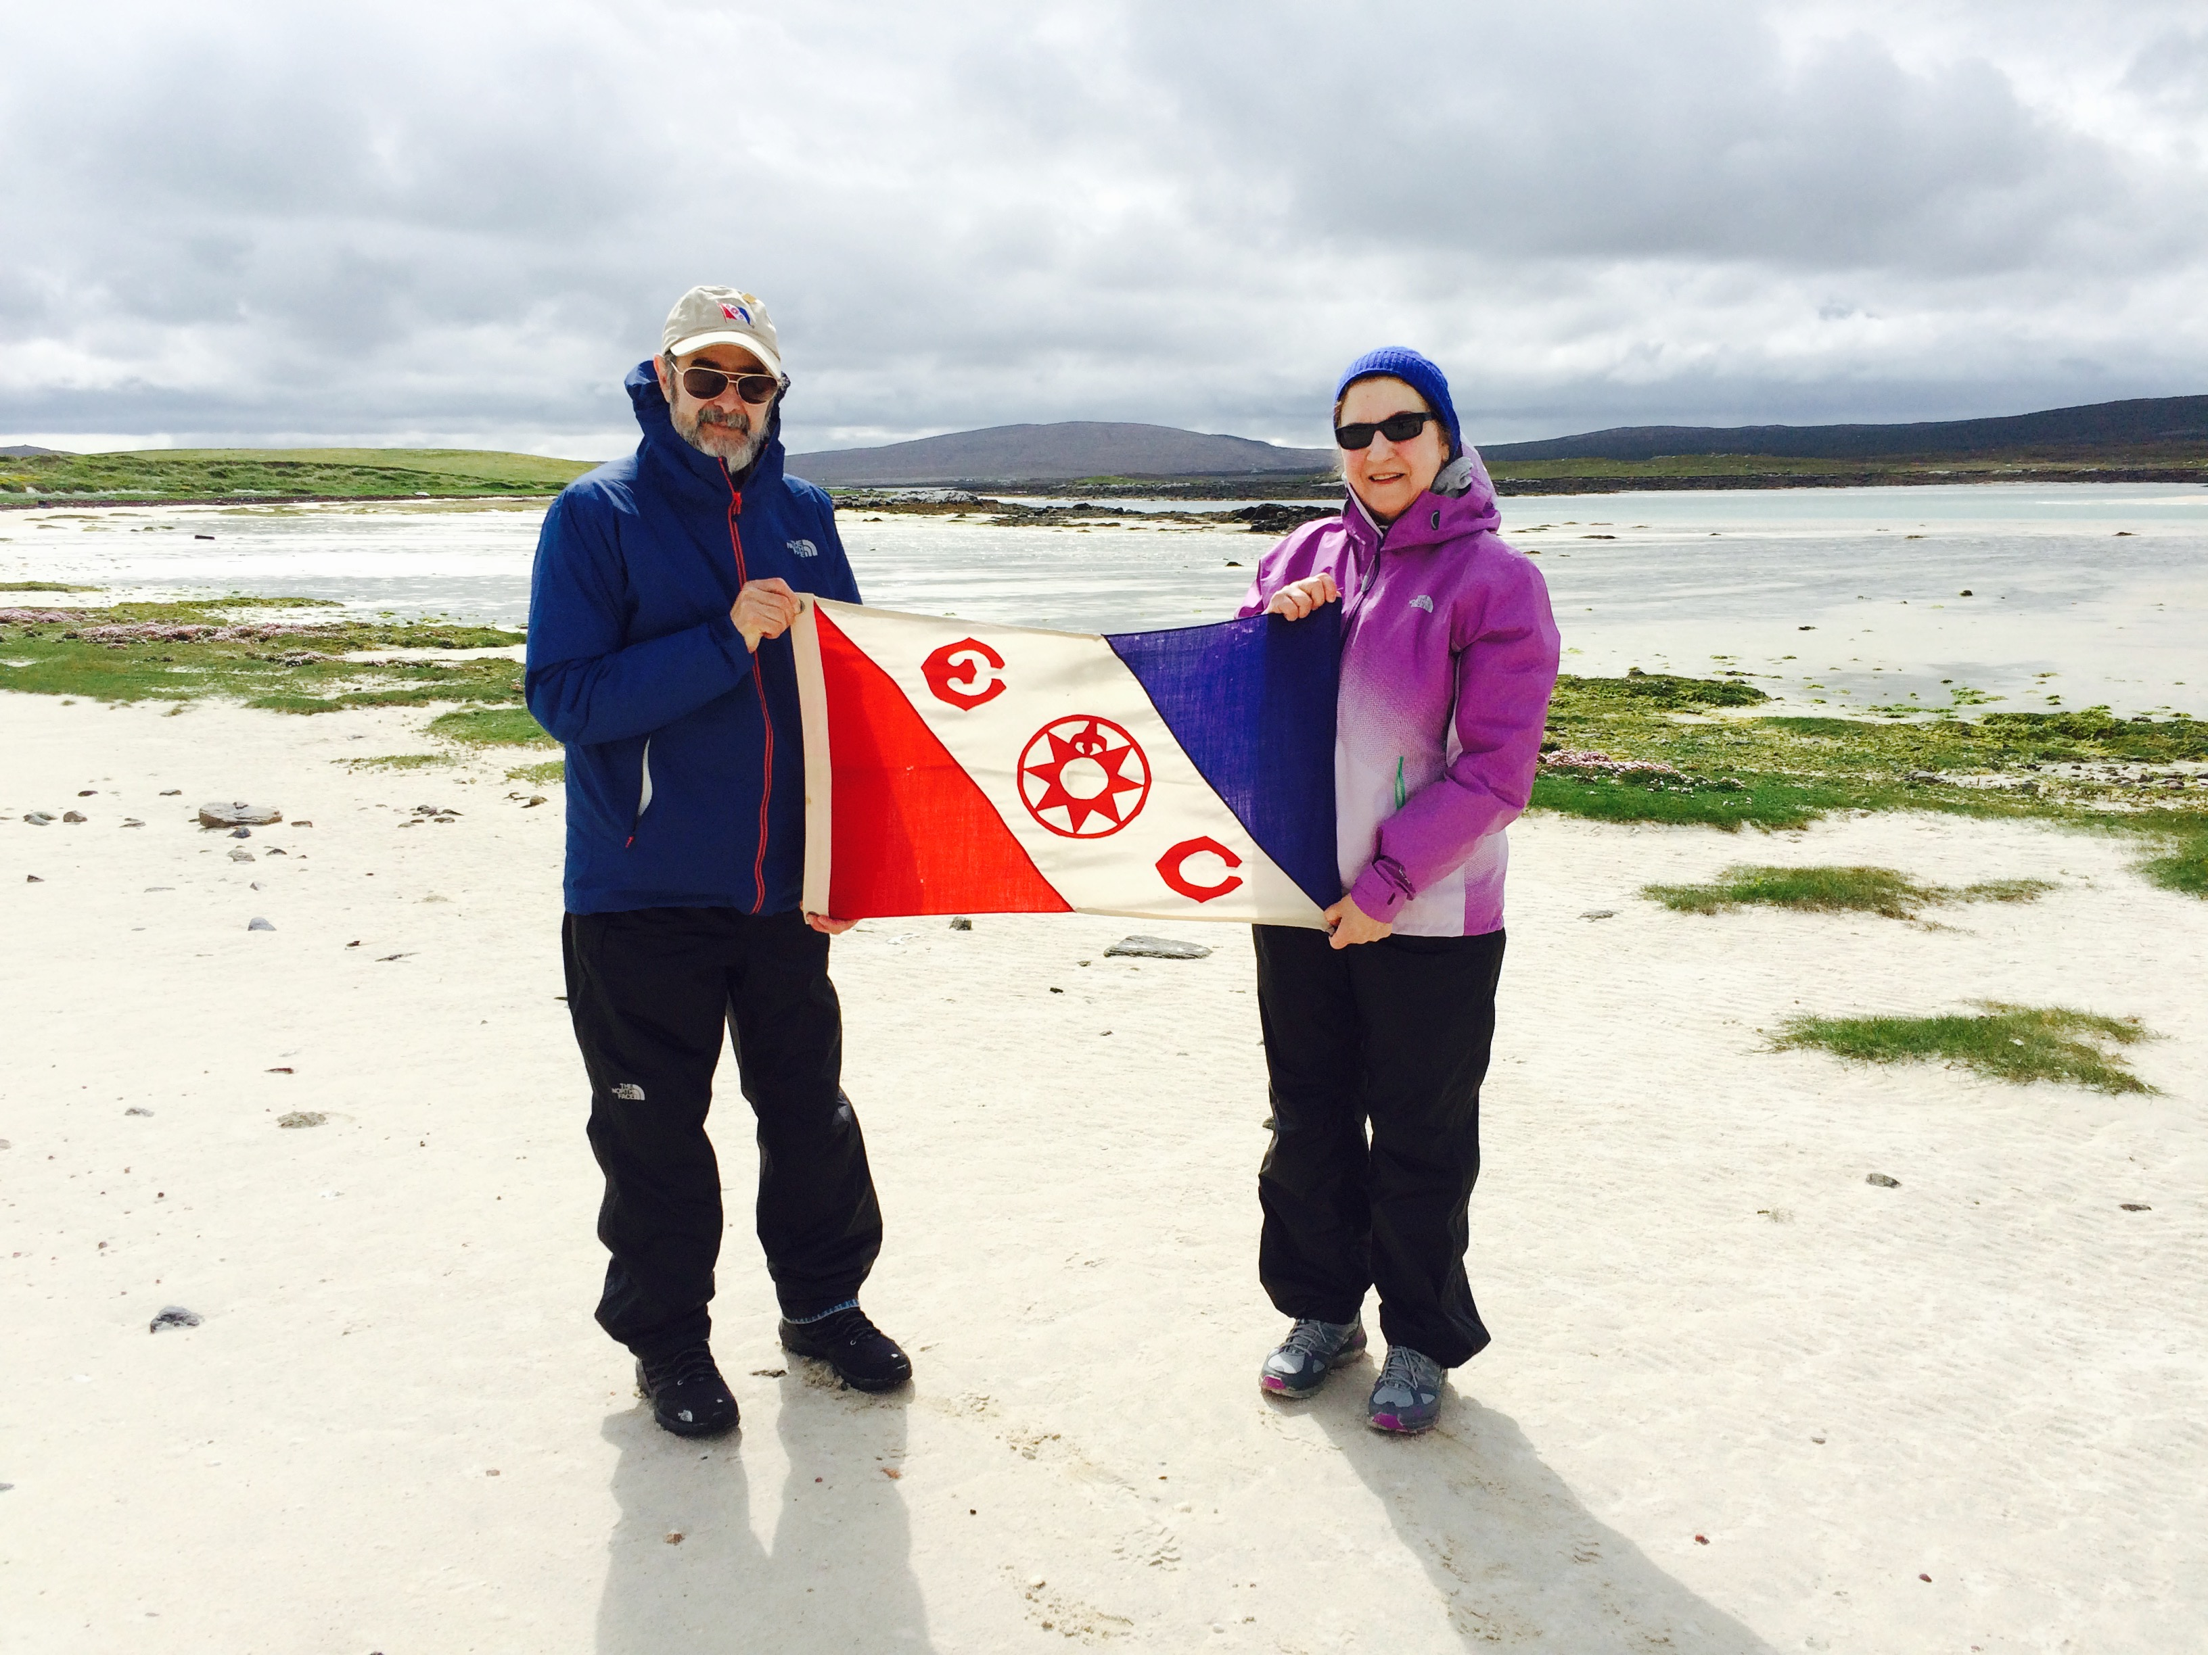

Rodrick B. MacLennan and June Julian, Isle of Vallay, Scotland

June Julian and her husband, Rodrick B. MacLennan, have been awarded the prestigious Explorers Club Flag again this year for their Isle of Vallay Archaeology/Climate Change Project in the Outer Hebrides. Their important research has implications for global erosion of coastal heritage due to climate change. Since 1918, the Explorers Flag has been carried on hundreds of expeditions: to outer space, to both Poles, to the deepest ocean, and to the highest peaks in the world. Hoping to return again this summer, their continuing research objective is to record the current status of those Archaeology sites first discovered by 19th cen. archaeologist Erskine Beveridge on the Isle of Vallay, Scotland, as impacted by climate change. Last year, they have published significant information on the status of endangered heritage sites in North Uist and Vallay, and have added their findings to several official Scottish databases: SCHARP (Scottish Coastal Heritage at Risk) , SCAPE (Scottish Coastal Archaeology & The Problem of Erosion), and Taigh Chearsabhagh (North Uist Museum and Art Center. They are grateful for the sponsorship of The Explorers Club, The North Face, and Caledonian MacBrayne Hebridean Ferries, and are currently seeking your support.

For further information:
Rodrick B. MacLennan
https://www.doublediamondarchaeology.org/

Dr. June Julian
http://www.junejulian.nyc

