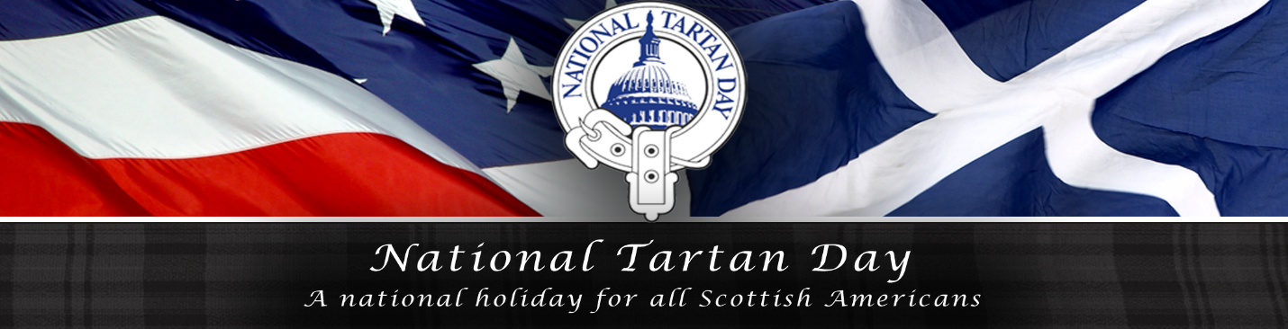
Annual Symposium and Reception – RSVP Form

Wednesday, April 10, 2019
DACOR Bacon House
1801 “F” Street, NW, Washington, DC 20006

PROGRAM

3:00PM - Opening Symposium Panel: Creating the Tartan, Our Cloth
of Identity – From The Perspective of Weavers and Designers

Clare Campbell, Weaver & Tartan Designer, The Prickly Thistle, The Black Isle, The Highlands, Scotland

Peter Wilson, Tartan Designer and Merchant, Great Scot International, Charlotte, NC

Gary Campbell, Special Programs Administrator, University of the Highlands & Islands, Inverness, Scotland

5:00PM - Cocktail Reception & Awards Ceremony: Beer & Wine, Scotch-
Tasting, Heavy Hors d’Ouvres, Musical Entertainment, and More

“Greetings from Scotland” -Joni Smith, Scottish Gov’t Counselor
for North America

Poetry Reading: Katie Ailes, DC St. Andrew’s Society Scholarship
Recipient & PhD Candidate, Strathclyde University

Piping and Fiddling – Peter Walker (“The Devil’s Tailor”)

Presentation of the Annual Tartan Day Award to Rev. Dr. Douglas
Kelly, President, Scottish Heritage, USA, by the Scottish Coalition

7:00PM - Closing Symposium Panel: The Impact of Brexit on Scotland

Andrew Morrison, Viscount Dunrossil, Honorary British Consul General, San Antonio, TX

Andrew Hughes Hallett, Professor Emeritus of Public Policy & Internat’l Economics, George Mason University, Fairfax, VA

Dana Linnet, Senior Manager, Gov’t Affairs, Lockheed Martin Corp., & Former Principal Officer, U.S. State Dep’t Consulate General, Edinburgh, Scotland

Please RSVP by Monday, April 8, 2016 – See Instructions Below

The cost of this year’s Symposium and Cocktail Reception is $40.00 per person.

This fee gets you into both the Symposium (two panels) and the Reception and Awards Ceremony.

No tickets will be sold at the door – RSVP and payment in advance is required. A Guest List will be maintained at the door for check-in.

Dress is Highland Day Wear or Business Attire (coat & tie for the gentlemen). The wearing of the tartan by all is strongly encouraged but never required.

If questions, contact John King Bellassai, Vice President, NCTDC, and Symposium Chairman, at (202) 258-4876 or at j.bellassai@yahoo.com.

You may RSVP electronically at our website: www.dctartanday.org and make your payment of $40 per person through Paypal,

or you may RSVP via US Mail and make your payment of $40 per person by check, made payable to “NCTDC” and mailed to:
Kathy Garrity, President, National Capital Tartan Day Committee
9361 Birchwood Ct. Manassas, VA 20110

Name_______________________________________________

Street Address___________________________ _____________

City___ __________________State_________Zip_____________

Email__________________ __Phone_______________________

Attendees: ___________________________________________

______________________________________________________________
NOTE: The National Capital Tartan Day Committee, Inc. (“NCTDC”) is a nonprofit charitable and educational organization, incorporated in the District of Columbia, which has been certified as a 501(c)(3) tax-exempt organization by the Internal Revenue Service. NCTDC’s sole purpose is to promote the Tartan Day holiday in and around our Nation’s Capial. All contributions to NCTDC are tax deductible, to the extent permitted by federal law.

